Urban waste collection aid - UWC 2.0
Urban waste management is one of several significant problems faced by many countries in the world and thus considered one of the important points to be improved in Sustainable Development Goal (SDG) 11: sustainable cities and communities and SDG 6: clean water and sanitation. Particular attention is given to developing countries that continue to prioritize development and economic growth. In urban context, solid waste management is costly and ineffective. Improvement of waste collection and management is emphasized by governments and organizations for positive impacts on cities, societies and environments.
Waste collection is often designated to an organization that provides professional waste management services. A typical waste collection process involves (1) back officers, who operate a central system to create calendar, coordinate front collectors and janitors ,(2) collectors, who drive different types of vehicles and (3) janitors who manually collect garbage from Major Collecting Points (MCPs). Calendar and tasks were assigned among teams of janitors and coordinated by back officers. These assignments are often arranged in a weekly basic. Back officers also plan which vehicles to use and their routes. This planning activity happens every month. Everyday, the back officers sent messages with information about collecting route and time to collectors and janitors. Janitors use trollers (see Figure 1b) to collect garbage in their assigned areas and deliver to the MCPs. Collectors will pick up garbage from all janitors at a MCP. One collector drives only one vehicle during his working shift. The collector will drive through several MCPs with a predetermined route by back officers.
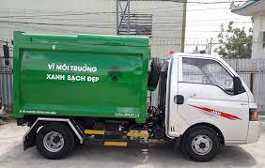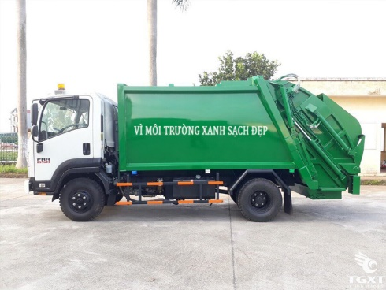  Figure 1a. Collecting vehicles | 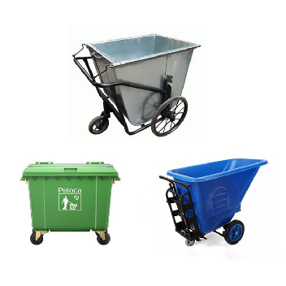  Figure 1b. Trollers

Organization X is contracted to develop an information management system called UWC 2.0 in order to improve efficiency of garbage collection of Service provider Y. The solution will include a Task Management module that allows:
Back officers to:
- Have an overview of janitors and collectors, their work calendar
- Have an overview of vehicles and their technical details (weight, capacity, fuel consumptions, etc)
- Have an overview of all MCPs and information about their capacity. Information should be updated from MCPs every 15 minutes with the availability of at least 95% of their operating time.
- Assign vehicles to janitors and collectors
- Assign janitors and collectors to MCPs (task)
- Create a route for each collector. Assigned route is optimized in term of fuel consumption and travel distance.
- Be able to send message to collectors and janitors
Collectors and janitors to:
- Have an overview of their work calendar
- Have a detail view of their task on a daily and weekly basic. All important information should be displayed in one view (without scrolling down).
- Be able to communicate with collectors, other janitors and back officers. The messages should be communicated in a real-time manner with delay less than 1 second.
- Check in / check out task every day
- Be notified about the MCPs if they are fully loaded
There are some constraints to the development of UWC 2.0. There exists a current system UWC 1.0 with a database. UWC 2.0 is expected to import and to use the existing data from UWC1.0. It is expected that the Task Management to be inter-operable with the UWC 1.0 as much as possible. The system should be able to handle real-time data from at least 1000 MCPs at the moment and 10.000 MCPs in five years. UWC 2.0 system interfaces should be in Vietnamese, with an opportunity to switch to English in the future.
---------Task ----------
Task 1: Requirement elicitation | 1.1 | Identify the context of this project. Who are relevant stakeholders? What are their current needs? What could be their current problem? In your opinion, what benefits UWC 2.0 will be for each stakeholder?
Task 1: Requirement elicitation | 1.2 | Describe all functional and non-functional requirements that can be inferred from the project description. Draw a use-case diagram for the whole system
Task 1: Requirement elicitation | 1.3 | For the Task assignment module, draw its use-case diagram and describe the use-case using a table format
Task 2: System modelling | 2.1 | Draw an activity diagram to capture the business process between systems and the stakeholders in Task Assignment module
Task 2: System modelling | 2.2 | Proposal a conceptual solution for the route planning task and draw a sequence diagram to illustrate it.
Task 2: System modelling | 2.3 | Draw a class diagram of Task Assignment module as comprehensive as possible
Task 3: Architecture design | 3.1 | Describe an architectural approach you will use to implement the desired system. How many modules you plan for the whole WMC 2.0 system? Briefly describe input, output and function of each module
Task 3: Architecture design | 3.2 | Draw an implementation diagram for Task Assignment module
Task 4: Implementation – Sprint 1 | 4.1 | Setting up. The team creates an online repository (github, bitbucket, etc) for version control. folders this stage, no need for a database to store all menu items, customers, etc. Data can be hard coded in code files.
Task 4: Implementation – Sprint 1 | 4.2 | Adding documents, materials and folders for Requirement, System modelling and Architectural design. Use the selected version control system to report the changes to these files/
Task 4: Implementation – Sprint 1 | 4.3 | Implement MVP1 – design an interface of either a Desktop-view central dashboard for Task Management for back-officers OR a Mobile-view Task assignment for Janitors and Collectors. Decide yourself what to include in the view. Design use a wireframe tool.
Task 5: Implementation – Sprint 2 | 5.1 | Implement MVP2 – realize the design in MVP1 with a programming language (HTML, Javascript, Python, C#, etc)
Task 5: Implementation – Sprint 2 | 5.2 | Demonstrate the whole project from Task 1 to Task 5

